#Faith4DACA Supreme Court Toolkit June 2020

Join the #Faith4DACA movement and national Home is Here Campaign as we celebrate the Supreme Court (SCOTUS) on Deferred Action for Childhood Arrivals (DACA) and take next steps to secure immigrants rights.

Toolkit Contents

Background
Actions to Take
Resources
Credit

Background

SCOTUS Rules DACA is Here to Stay! (For Now)
On June 18, the Supreme Court ruled (5-4) that President Trump’s attempt to end the successful Deferred Action for Childhood Arrivals (DACA) program was “arbitrary and capricious.” The ruling reverses the Trump administration’s termination of the DACA in 2017. This means that the program stands, as established through the memo by DHS Secretary Napolitano in 2012, for the time being.
The decision offers a moment of reprieve for the 700,000 DACA recipients who have been awaiting a ruling for months, now in the midst of a global public health crisis. Many DACA recipients work in essential occupations through these difficult months of pandemic, putting their lives on the line to serve this country. As teachers, medical professionals, lawyers, and more, DACA recipients are woven into the fabric of our society and are vital members of our communities.
With this decision, USCIS/DHS will continue accepting and processing DACA renewal applications. The Supreme Court decision also requires USCIS/DHS to accept new (“initial”) DACA and advance parole (permission to travel) applications once again. We do not know whether the Trump administration will take action limiting these options.
The Supreme Court did not determine whether the program was sound or lawful, it simply narrowed in on the Department of Homeland Security’s manner of terminating DACA. The court found that it was done improperly and in violation of the Administrative Procedure Act. As a result, DHS’s termination is remanded back to the agency. The agency could start the process of ending DACA anew.
The Interfaith Immigration Coalition (IIC), along with direct service organizations and immigrant’s rights advocates, will continue to work towards passing legislation that fully embraces the undocumented immigrant youth in our communities. Ultimately, only legislation–not litigation–can provide a permanent solution for DACA recipients and their families. And finally, as we respond to the Supreme Court decision on DACA, we join Black advocates as they endeavor to remove the added enforcement and criminalization of Black and brown communities.

Our Demands
Immigration rights advocates must seize this moment to demand that:
- Trump halts deportations of undocumented immigrants, including anyone who has or has ever had DACA status.
- Trump automatically extends DACA permits that expire in 2020 by two years.
- Congress passes a permanent solution that helps people without hurting people, and defunds ICE and CBP. The lives of immigrant youth are not leverage for a negotiation. The Senate must act now to pass permanent protections by bringing long-overdue legislation, like the bipartisan Dream and Promise Act, to the floor for a vote.
- State and local leaders eject ICE and CBP from our communities; sign on to our letter; and work to provide free COVID-19 testing, treatment, and services for all, regardless of immigration status.
- In solidarity with Black advocates, our nation must defund the police, end the war on Black communities, and invest in Black communities.

Continued Attacks on DACA and Black, Indigenous, People of Color
In light of COVID-19 and pervasive systemic racism, it must be said: immigration is a Black issue, too. Justice cannot be served until Black community members in our midst, many of whom are also immigrants, are able to live full and prosperous lives. There are more than 10,000 Black immigrant youth who have been protected from detention and deportation because of DACA. And there are thousands more who would have been protected if DACA was not illegally rescinded by the Trump administration in 2017.
The fight for justice for all immigrants is part of a larger racial justice movement that demands full equality and investments in the communities of Black people and communities of color.

People of Faith Are Called to Solidarity and Action
Trump could still rescind DACA. If DACA were to end, hundreds of thousands of people who are Americans in every way but their status would be vulnerable to deportation. People would eventually lose their work permits and their way to make a living. We cannot let this happen. We must use our voices to protect our community and let everyone know that #HomeIsHere #DefendDACA #Faith4DACA.

Faith communities across traditions have repeatedly demonstrated an unwavering commitment to immigrant youth and their families. Faith communities have for years written letters, made statements, issued comments and alerts, joined Amicus briefs, engaged in national actions, and supported grassroots actions in solidarity with DACA recipients and the DACA program.

Faith partners have likewise in recent months called for swift passage of the bipartisan Dream and Promise Act, a unified and stand-alone legislation that would provide a path to citizenship for all Dreamers as well as Temporary Protected Status (TPS) and Deferred Enforced Departure (DED) holders, which has passed the U.S. House of Representatives, but has not moved in the U.S. Senate.

We, as faith communities, must continue to answer the call to take action in solidarity with DACA recipients and undocumented youth in response to the Supreme Court’s decision to block President Trump’s efforts to end DACA. We invite people of all faiths to stand in solidarity with immigrant youth by dedicating a time of prayer or testimony in support of DACA at your regular weekly worship service to pray with Dreamers and all undocumented youth. We look to achieve justice and peace, not just for Dreamers, but for all Black, indigenous, and people of color who are subject to oppression and systemic racism.

We also encourage you to post your prayers on social media, invite Dreamers to speak at your virtual worship sessions, and organize an online action to show the country that people of faith support undocumented youth in this critical moment.

Actions to Take
Here are actions you can take to support #Faith4DACA and #HomeIsHere Campaign

- Organize a Virtual Vigil or Rally to Support DACA Recipients and Undocumented Youth
- Organize a public witness event to educate the broader public about the importance of protecting DACA and TPS.
  - How to organize a virtual vigil resources are below.
  - Media resources are below.
- Join “Monday Morning DACA Prayers,” led by DACA leaders and allies, at 9:30-10 ET every Monday, and organize your own ways locally to build partnerships between DACA leaders and faith communities.
  - Register for Monday Morning DACA Prayers here.

- Educate Followers on Social Media
- Share these graphics.
- Post a prayer or video and promote your actions on your social media.
- Use the hashtags #Faith4DACA, #HomeIsHere, and #HereToStay.
- Join the Virtual Prayer Chain. Take over social media with our prayers with DACA recipients and undocumented youth:

Promoting the Virtual Prayer Chain
1. Record a video of yourself holding a #Faith4DACA sign (download page here)

Say: My name is _________________ and I’m ______________ (faith tradition)

I am from ___________________ (city, state)

I pray with DACA recipients because_______________________

2. Upload your video to Twitter with the hashtag #Faith4DACA and tag the Interfaith Immigration Coalition (@interfaithimm). Tweet at your members of Congress.

3. Post the video to Instagram and Facebook with #Faith4DACA. Make the post public on Facebook and tag Interfaith Immigration Coalition and your members of Congress!

- Sample social media posts:
  - DACA recipients deserve permanent protection!

My faith community stands with DACA recipients and all our immigrant neighbors. In light of the #DACADecision, we call on Congress and @realDonaldTrump to pass permanent solutions for Dreamers.
#Faith4DACA #HomeIsHere

  - Trump could still rescind DACA.
Raise your voice and urge @realDonaldTrump and your Members of Congress to immediately pass permanent solutions, like #HR6, that will protect Dreamers and other immigrants. http://bit.ly/Faith4DACApetition #Faith4DACA #HomeIsHere
  - People of faith: Urge @realDonaldTrump to provide permanent protection to the 800,000 immigrant youth who are part of the DACA program.
These young people are our friends, family, coworkers, and vital members of our communities. Their #HomeIsHere! #Faith4DACA

  - People of faith must speak out and demand that @realDonaldTrump halt deportations of our undocumented community, including anyone who has or has ever had DACA status.
#Faith4DACA #HomeIsHere #HereToStay

  - Over 200,000 DACA recipients are essential workers serving on the frontlines of the #COVID19 pandemic.

They deserve permanent protection and to be recognized as the invaluable members of our communities that they are. #Faith4DACA #HomeIsHere

  - 85% of Americans are in favor of allowing Dreamers to stay in the U.S.
It’s time for our laws to reflect this. Join us in urging Congress and @realDonaldTrump to #DefendDACA and provide permanent protection to Dreamers and all members of our immigrant community. #Faith4DACA #HomeIsHere
  - People of faith: Speak up for DACA! 📢
The fate of 800,000 young people hang in the balance. Here’s how you and your faith community can take action: [link to toolkit]
#Faith4DACA #HomeIsHere
  - Contact your state and local leaders and urge them to:
- Eject ICE and CBP from your community
- Provide free COVID-19 testing, treatment, and services for all—regardless of immigration status.
#Faith4DACA #HomeIsHere
  - The #DACA ruling is a testament to the decades of organizing and advocacy by Black and immigrant communities and civil rights groups who have built the momentum that brought us DACA and #HR6.
We will continue the fight. #Faith4DACA
- Connect With Your Elected Officials
- Topline Messaging for Members of Congress:
  - Demand Trump halt deportations of DACA recipients.
  - Demand Trump automatically extend DACA permits that expire in 2020 by 2 years.
  - Pass the Dream and Promise Act of 2019 (HR6 and defund ICE & CBP).
  - Reject immigration-related proposals that seek to eliminate pathways to the country, create added barriers for immigrants, or increase enforcement attacks against immigrants.
  - Congress: Pass permanent solutions that help people without hurting people and defund ICE & CBP.
  - State and Local Leaders: Get ICE and CBP out of our communities; sign onto our pledge; and work to provide free Covid19 testing, treatment and services for all, regardless of immigration status.
  - In solidarity with Black people, we call for defunding of police, investments in Black communities and ending the war on Black people.
Ask them to make a public statement in support of DACA recipients by sharing stories of DACA recipients and their families in statements, floor speeches, op-eds, and on social media.

- Call your House Representative and Two Senators at Capitol switchboard (202) 224-3121 and tell them to support DACA recipients:
  - Call 3 times to connect to your 1 Representative and 2 Senators.
  - Sample script:
The Supreme Court saved DACA for now, but the Trump administration still wants to end it. We urge you to support the Dream Act of 2019 (S.874) or the Dream and Promise Act of 2019 (HR6)- common-sense legislation that would provide a pathway to citizenship for people eligible for Deferred Action for Childhood Arrivals (DACA). The cornerstone of responsible immigration reform is compassion and a firm foundation of principles and values.
- Tweet at your Elected Officials.
  - Find your Senators and Representatives’ Twitter handles here.

Sign the #FaithDACA Petition to the Senate
Join us in urging the Senate to invest in permanent and healing solutions for DACA-mented youth and their families by passing a clean Dream and Promise Act immediately, as expressed in the bi-partisan H.R. 6 and in S. 874, to give DACA recipients and eligible undocumented youth a pathway to citizenship.

Sign the petition to the Senate today: http://bit.ly/Faith4DACApetition

Sample Social Media Posts to Promote the #Faith4DACA Petition
DACA stands, for now, but our immigrant community deserves permanent protection. Sign the petition asking the Senate to protect DACA recipients, TPS holders, and other immigrants now: http://bit.ly/Faith4DACApetition
#Faith4DACA #HereToStay #HomeIsHere

Trump could still rescind DACA. Raise your voice and urge the Senate to immediately pass a permanent solution, like #HR6, that would protect Dreamers and other immigrants: http://bit.ly/Faith4DACApetition #Faith4DACA #HereToStay #HomeIsHere

Add your name! 📝 Sign the #Faith4DACA petition to ask the Senate to give #DACA recipients and undocumented youth a pathway to citizenship. Learn more and sign the petition here: http://bit.ly/Faith4DACApetition #HereToStay #HomeIsHere

Immigrants deserve protection and a pathway to citizenship! Ask the Senate to bring the American Dream and Promise Act of 2019 (H.R. 6) and the Dream Act of 2019 (S.874) forward for a vote. Sign the #Faith4DACA petition here: http://bit.ly/Faith4DACApetition #HereToStay #HomeIsHere
- Dedicate a Prayer, Testimony, or Message in Your Faith Community
- Share the stories of DACA recipients or undocumented youth to move your congregation and community to action in support of DACA #Faith4DACA. Contact United We Dream or other immigrant-led organizations for assistance.
- Stand in solidarity with DACA recipients by praying with and for their families and other members of our communities who are facing the possibility of losing protection from deportation.
- Share and use these resources: Prayer Resources, Stories of DACA Recipients, Quotes of DACA Recipients, and an Interfaith DACA Prayer Litany.

- Write An Op-Ed or Letter to the Editor for your Local Newspaper
- Writing for your local newspaper or your church newsletter is a great way to both educate your community members and demonstrate support for DACA recipients.
- See Draft Op-Ed. For tips, go to www.theopedproject.org
- See Draft Letter to the Editor. Here are Tips on how to create an LTE.
- Contact media@interfaithimmigration.org for assistance

Resources

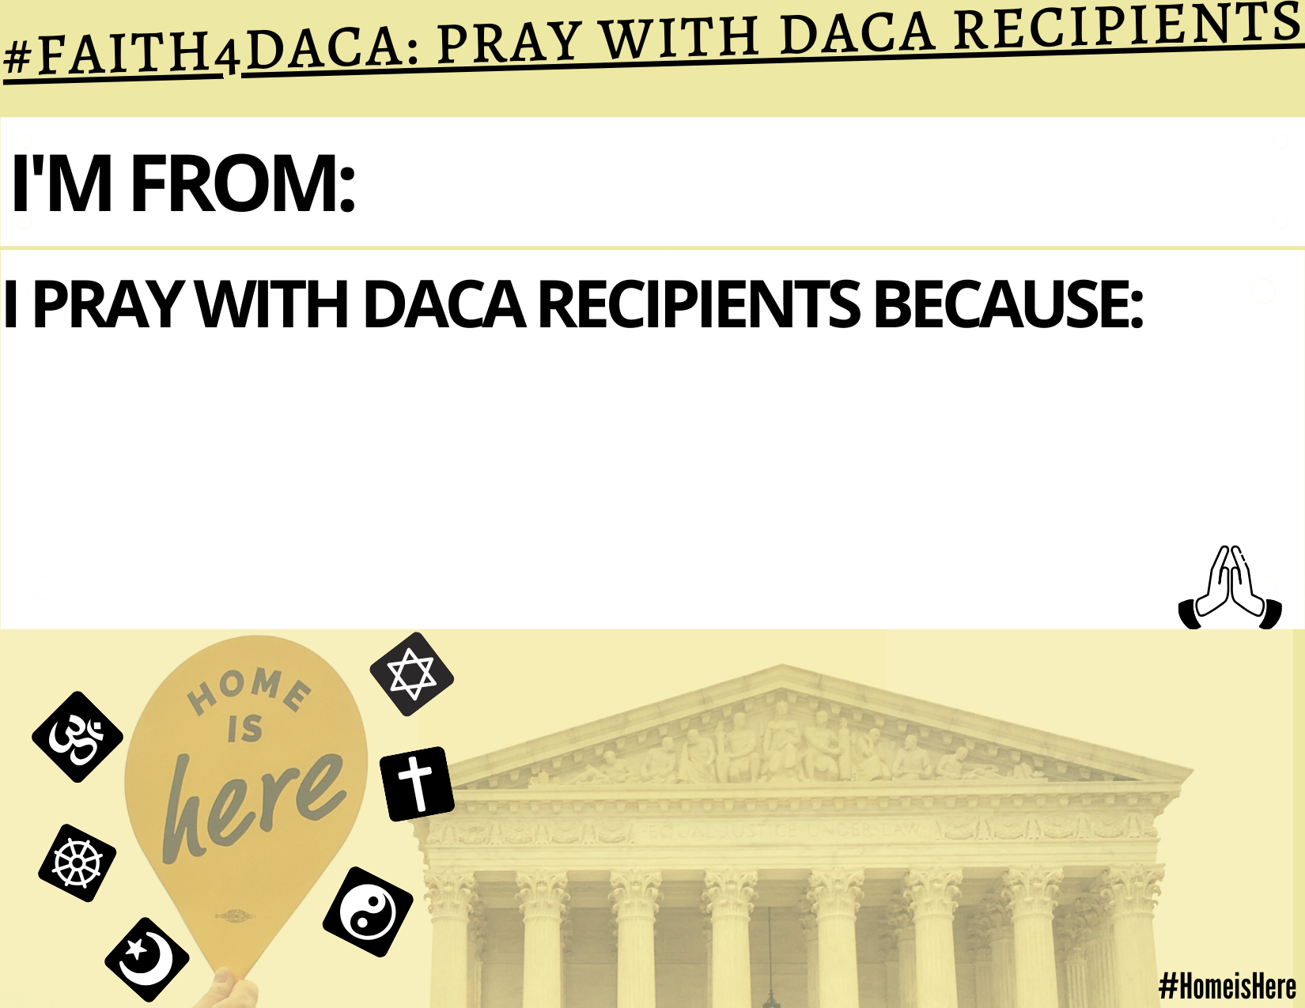

How to Host a Virtual Interfaith Vigil

Hosting interfaith vigils—including virtual ones in this time of social distancing concerns—provides the opportunity for faith leaders to express how welcoming immigrants is part of all faith traditions, reflecting on the deep scriptural and spiritual roots of our work to support immigrants. Even small events, multiplied across the country, will send a powerful message to the Trump administration, Congress, and the Supreme Court that welcoming immigrants and DACAmented youth are moral issues that are important to people of faith and conscience.

Steps to a Successful Virtual Prayer Vigil:
- Coordinate a virtual prayer vigil with faith leaders, immigrants’ rights groups, refugee resettlement agencies, immigrant leaders, community members, and if possible local elected leaders. Use Zoom or other available platforms to gather.
- Collect the social media identities of your key partners; including Twitter handles, Facebook sites, Instagram--or wherever are the primary ways that your partners virtually communicate and can influence primary targets/audiences.
- Identify the core leaders and speakers, make sure there are impacted people, including undocumented individuals and faith and interfaith organizations who are invited to help plan and speak at your gathering.
- Consider inviting elected officials including Representatives, Senators, City Council Members, or the Mayor to join your virtual discussion.
- Be clear about your goals, what you want to accomplish, and how many people you hope will join the event.
- If you can meet with a small group in person, identify the best location for the vigil, which is generally somewhere central in a symbolic memorial, state capitol, park or city hall. If you are meeting only virtually, share images of key locations where decision makers work, or of locations symbolically important for dreamers.
- If you are meeting virtually, practice with your technology ahead of time, meet ahead with presenters online, and be sure all participants have the needed links for connecting. If you are having an allowable event with social distancing, apply for any permits needed for the location; reserve or order any equipment you’ll need such as microphones, cameras, banners, candles, projectors; and make sure you can access electrical outlets.
- Choose a time of day best for attendance and media -- most news reports take place at 5-6 PM and 9-10 PM, so a few hours before those time blocks is best for press events.
- Promote the event through social media, public service announcements, flyers, websites, and congregation bulletins. Use creative imaging to catch attention!
- Agree on messaging and talking points.
- Encourage those who are dialing in to make signs that are consistent with your messaging and agreed upon ahead of time--and invite them to even “hold and show them” during your event to generate interest. Develop signage to share on your screen as you talk.
- Assign specific talking points to each speaker and ensure they have time limits.
- Invite the media by issuing a media advisory and following up with a press release after the event.
- Invite participants at the virtual vigil to be part of further action and advocacy by taking actions such as writing and calling the White House and their Representatives and Senators, posting their commitment for DACA recipients, inviting DACA recipients to testify in their virtual services, and more.

The set-up for the vigil should ensure that all faiths are respected and welcomed with awareness and consciousness. If you are holding an interfaith virtual event, drawing on multiple faith traditions and rituals can make vigils much more powerful, raising the creative and dramatic tension.

Ask clergy attending (even virtually) to wear collars, stoles, robes and any other appropriate religious attire.

As social distancing allows, you may consider:
- Procession with candles to symbolic location. If your action is virtual, use images or a video to ask persons to “virtually process”.
- A Prayer Wall with handwritten prayers for immigrants. If you are virtual, ask for prayers to be shared via chat.
- Lift up stories in sacred texts.
- Highlight passages in scripture and send electronically to Members of Congress.
- Collect and deliver prayers electronically to your Senators and Representatives.
- Make visuals – photos, drawings, art, etc.that show the consequences of the loss of DACA protections.

Sample Vigil Program:
- Welcome—a few words about the focus and purpose of your vigil. Why now? What’s the concern? Who’s affected? How can this vigil convince your members of Congress to support DACA? What values shape your faith traditions’ response to these concerns? This may take the form of brief comments from one of your speakers, or a welcome and an opening prayer.

Music- Invite local musicians who share similar values to join your vigil, you can have them do one or two songs throughout the program. Choose songs that are connected to the cause, or songs that everyone knows and can sing along.

Opening Prayer—Ask clergy or key lay leader to open with a prayer song—A singer, choir or instrumentalist can perform, or a few singers can lead participants in singing.

Speaker—A personal story from a local community member of how the outdated and unjust immigration system has impacted families. More than one story can be integrated throughout the program as well. Creative Ritual: Integrate creative symbols or rituals from faith traditions that draw more attention to the importance of immigration reform (see above suggestions)

Prayer—One person may lead the prayers, or you might invite several faith leaders to pray according to their traditions. Involve vigil participants in praying a refrain throughout your prayer time, or pray in a circle so everyone has the opportunity to pray. Consider offering prayers in multiple languages.

Song & Closing—reiterate the focus and purpose of your vigil, and send participants off with a call to welcome newcomers and raise their voices in the public sphere to stop the deportations. Consider a procession or march to another symbolic and strategic location.

Media Resources

If you have planned a #Faith4DACA event or vigil, we encourage you to reach out and invite members of the media. Look online at the local publications or outlets you would like in attendance and search for past articles on immigration or refugees, then consider pitching your event to reporters who frequently cover those issues or other community issues if there is not a designated immigration or refugee reporter.

Consider inviting the editorial director at your local newspaper. By inviting members of the press, you will be able to further share our message of welcoming to a larger audience and also inspire local media to cover immigration issues more frequently in a positive way that highlights broad community support for DACAmented youth and TPS recipients.

To invite multiple members of the press, send a media advisory at least two full business days ahead of the event. Ideally, send the media advisory one week before the event and then again the day before your event.

Please see the draft pitch email for media invitation, as well as the media advisory below.

Draft Pitch Email for Media Invitation and Follow Up from Advisory

Hello,

I hope you are well! I wanted to let you know of a potential story opportunity in regards to the continued debate over the Deferred Action for Childhood Arrivals (DACA), in CITY/STATE and the ongoing response from communities to protect the program and DACA recipients. On DATE, ORGANIZATION will host an interfaith vigil. Community leaders including LIST will join DACAmented youth, and other faith leaders to stand in solidarity with our immigrant neighbors and support DACA.

We will highlight the real people whose lives depend on this program.

I have attached the invitation flyer to this email with a full list of participants, but please let me know if you can attend and if you have any questions!

Sincerely,
NAME

DATE
For Immediate Release
Contact:
NAME, PHONE NUMBER

***MEDIA ADVISORY***
Date of Event, Time, Location

Local (Faith Group) Hosts (Vigil/Rally) in Support of DACA Recipients

Your City Name, State Abbreviation – As the (City/Town Name) community seeks to demonstrate interfaith support for the Deferred Action for Childhood Arrivals (DACA) and DACAmented youth, leaders from (Organization/Congregation) will host (event type) to show support for the DACA. They will be joined by XX (list other special guests, especially clergy or elected officials). Participants will discuss how DACA and DACAmented youth positively impact the community. All participants will be available for interviews before and after the event.

WHAT: Event type with faith and community leaders to welcome immigrants

WHERE: Address of event

WHEN: Date and time of the event

SPEAKERS: List of all speakers and their titles

DETAILS: Add event details such as security (if applicable), special visuals (religious symbols, art pieces, etc.), or any other important event information.

Credit
THE HOME IS HERE CAMPAIGN IS SPONSORED BY
CASA
CHIRLA
FIRM
FWD.US
MRNY
NAKASEC
NILC
UWD

